A000-Mex-Teotihuacan-Tlaloc-Statue-Terra cotta-300 BCE-450 CE

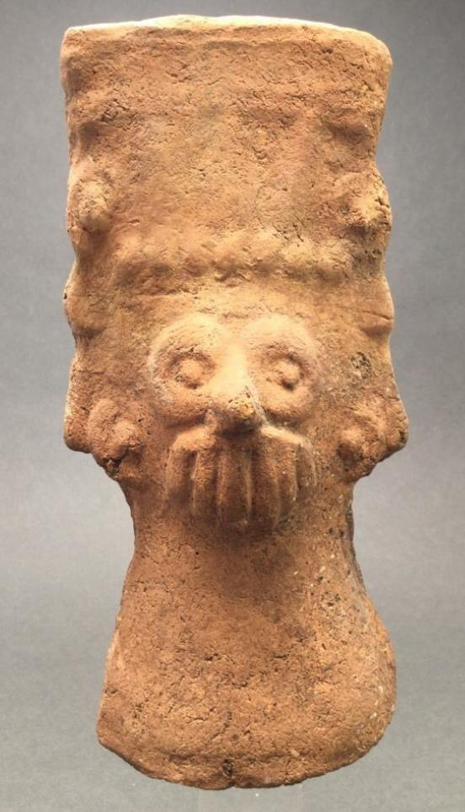

Case No.: 10

**Accession No.**

**Formal Label:**

**Display Description:**

**LC Classification:**

**Date or Time Horizon:**

**Geographical Area:**

**Map:**

**GPS coordinates:**

**Cultural Affiliation:**

**Media:**

**Dimensions:** 7.5" tall without base.

**Weight:**

**Condition:**

**Provenance:** Ex. Melvin Dwork collection, Shelter Island , NY

**Discussion:**

**References:**

Appendix:

